Kepner Tregoe Advanced Problem Management RCA Configuration
Platform: ServiceNow

1. Introduction
This document outlines the implementation process for the scoped application 'Kepner-Tregoe Advanced Problem Management RCA' in ServiceNow.
It includes importing the XML update set, validating modules and tables, configuring roles, and modifying the Problem form layout to include a related list.

2. Import XML Update Set for Scoped Application
Steps performed:
- Logged into the ServiceNow instance with admin access.
- Navigated to System Update Sets > Retrieved Update Sets.
- Used the 'Import Update Set from XML' option to upload the file.
- Opened the update set record, previewed it, resolved any warnings or errors.
- Successfully committed the update set into the instance.
Result:
- The scoped application 'Kepner-Tregoe Advanced Problem Management RCA' was successfully deployed.

3. Validate Application Menu, Module, and Table
Steps performed:
- Navigated to System Applications > Application Menus.
- Located the 'Kepner-Tregoe Advanced Problem Management RCA' application menu.
- Verified the presence of the module: 'Problem Analysis'.
- Confirmed the underlying table: x_ket_apm_problem_analysis.
- Validated all required fields in the form layout including: Number, Problem reference, Object(s), Deviation, True Cause, Proposed Fix, Assignment Group, Status, and Assigned To.
- Confirmed the existence of a related list 'Situation Appraisal' with sub-fields like Concern, Context, Action Items, Current Impact, Future Impact, Timeframe, etc.
Screenshot evidence of the table and fields:
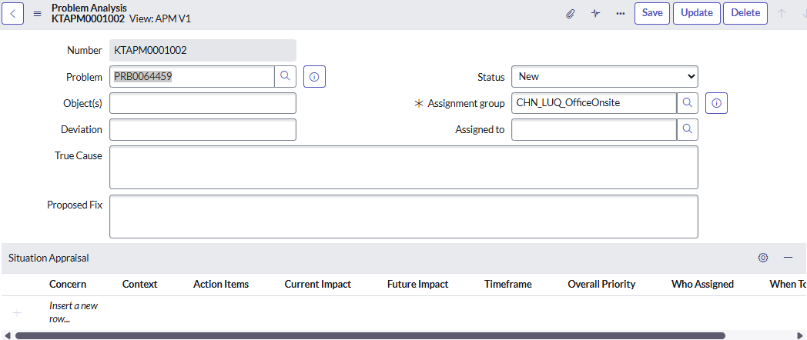

4. Configure Access Role
Steps performed:
- Verified the role 'x_ket_apm.user' under System Security > Roles.
- Assigned the role to relevant users for access to the Problem Analysis module.
- Verified access permissions and visibility through impersonation testing.
Result:
- Only users with the x_ket_apm.user role can access Problem Analysis records.

5. Add Problem Analysis Related List to Problem Form
Steps performed:
- Opened a Problem record.
- Navigated to Configure > Form Layout.
- Located 'Problem Analysis' under Related Lists and moved it to Selected.
- Saved the layout.
- Reloaded the Problem record to confirm visibility of Problem Analysis related list.
- Validated data linkage via reference field.
Result:
- Problem Analysis now appears as a related list in the Problem form.

6. Testing & Validation
Steps performed:
- Created test records under Problem Analysis module.
- Linked records with Problem tickets.
- Verified KTAPM prefix auto-numbering.
- Tested access using assigned roles and impersonation.
- Checked related list behavior and data consistency.
Result:
- Application is functionally complete and behaves as expected.
- No access issues found.

7. Outcome
- Application Kepner-Tregoe Advanced Problem Management RCA is fully implemented.
- The Problem Analysis module is accessible.
- Records follow the KTAPM numbering format.
- Related list is added to Problem records.
- Role-based access (x_ket_apm.user) is configured for proper security.

8. Conclusion
The Kepner-Tregoe Advanced Problem Management RCA scoped application was successfully implemented in ServiceNow.
This included importing the application, verifying structure, configuring form layouts, managing roles, and testing functionality.
The implementation enables structured root cause analysis tied to the Problem Management process with clear role-based control and easy record access.
All critical functions including table creation, role setup, and UI configuration were verified.

